**Unit 1 : Principles of Computer Science : Python Programming Project : Tic-Tac-Toe**

Tic-tac-toe (also known as noughts and crosses or Xs and Os) is a game for two players, *X* and *O*, who take turns marking the spaces in a 3×3 grid. The player who succeeds in placing three of their marks in a horizontal, vertical, or diagonal row wins the game.

The following example game is won by the first player, X:

Game of Tic-tac-toe, won by X

https://en.wikipedia.org/wiki/Tic-tac-toe

**Your task:**

Plan, develop, test and evaluate a Python implementation of this game

All your work must be handed in as a github repo. Instructions and information should be in markdown, png or pdf files, and all code and text files used must also be handed in.

You may develop your code in any jupyter notebooks or any other industry standard IDE

**Plan**

You must first plan your solution

1. **RULES**: Play the game a few times to fully understand the rules. Write the rules, simply, in your own words

-The game is played in a 3x3 grid

-There are two players, one player is an “X”, the other player is a “O”

-The game will be player one turn at the time, alternating them i.e: Player 1, then player 2, and so on.

- If one player gets to place three of his symbols on a row, then wins, i.e XXX. It doesn't matter if its on diagonal, horizontal or vertical

-If All the spaces in the grid are filled, and no one has managed to win, then the game ends in a draw.

1. **PLAN**: Make notes about what decisions you will need to make in your program
   1. Variables and constants and their types

Variables that i’ll need in my program:

* A function called drawBoard
* A function called is_GridFull
* A function called isSpaceFree
* Variable: game_Start
* Variable: player1_choice
* Variable: score
  1. Use of data structures and files

The function drawboard will print the grind in the screen for the user.

The function isSpaceFree will check if the grill is full, in order to allow or deny users to place themself in the grids .

The function is_GridFull will check if the grid is full to stop the game and decide a draw

Variable player1_choice will store the value of the user’s symbol (X or O)

Variable score will count and store the score

* 1. User interface - how the user will interact with the program. The messages they will receive.

The user will be able to see the grid with 9 spaces, then he will be asked to select a spot to place is X or O, introducing a number from 1 to 9 (1 being the top left, 9 being the bottom right).

Once the user inputs the position he wants to be in (in form of number) he then his symbol (X or O) will be outputted and presented in the grid.

The program will then ask the player number 2 to play, and repeat the previous process.

Once one player colocates three of his symbols (X’s or O’s) in a row, diagonal, horizontal or vertical a message will be outputted saying “Player X has won this game !” (X = number of player that won)

However if the grid fills up and there are no spaces left, the following message will be outputted:

“There are no winners because this is a draw! Play another match.”

If when the user is asked to input a location for his symbol (X or O) in form of number 1-9 and no valid is inputted, then the program will display a message saying “Incorrect input, please input a number 1 to 9”

If when the user is asked to input a location for his symbol (X or O) in form of number 1-9 and the grid chosen is already being used, then the program will display a message saying “Incorrect input, please input a number 1 to 9 that has not been used”

1. **ALGORITHM**: Design the algorithm as a flowchart
2. **TEST PLAN:** Create a comprehensive test plan using the following template: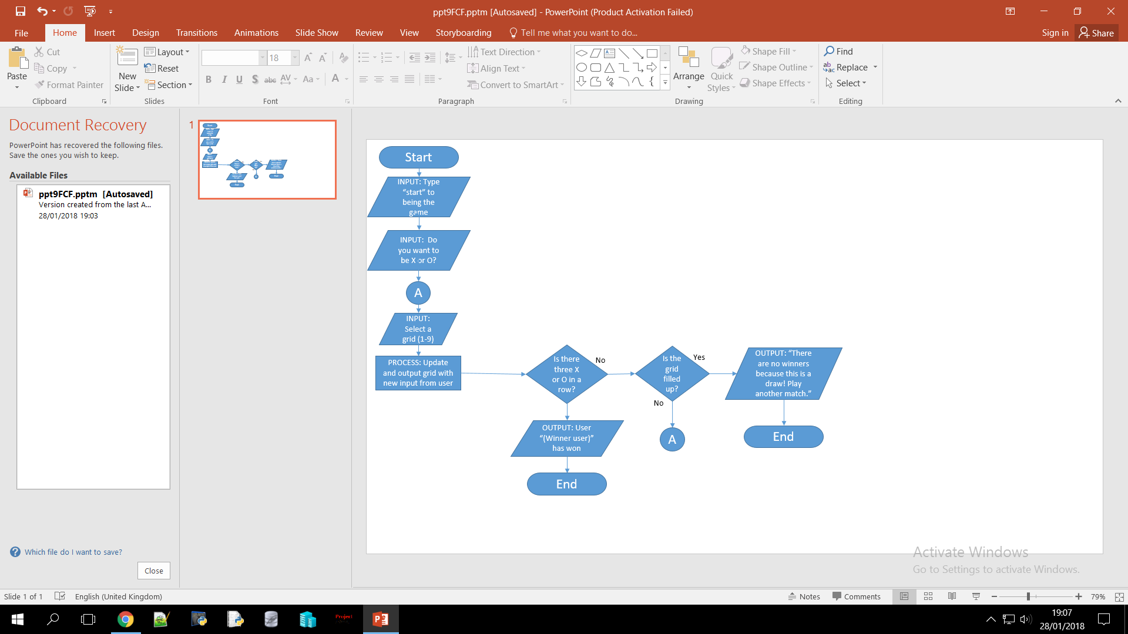

|  |  |  |  |
| --- | --- | --- | --- |
| Test Num | Description of Test | Test data | Expected outcome |
| 1 | To see if you can input a letter when you are asked to choose a grid position instead of a number | Invalid | Message saying “Incorrect input, please input a number 1 to 9” |
| 2 | To see if you can input two numbers when you are asked to choose a grid position instead of a number | Erroneous | Message saying “Incorrect input, please input a number 1 to 9” |
| 3 | Try to overwrite a value of a grid, for example put a X in grid 4, when there is a O already there | Erroneous | Message saying “Incorrect input, please input a number 1 to 9 that has not been used” |
| 4 | See if the program will accept two invalid inputs from the user when asked if he wants to be X or O I.E: R | Invalid | Message saying “Incorrect input, please input either X or O |
| 5 | See if the program will accept two different inputs from the user when asked where in the grid he wants to be i.e: 15 | Erroneous | Message saying “Incorrect input, please input a number 1 to 9” |
| 6 | See if the program will accept a number out if range in the grid i.e 95 | Extreme | Message saying “Incorrect input, please input a number 1 to 9” |
| 7 | See if the program can accept data that is near to be rejected i.e: 9 | Boundary | Data should be accepted normally |
| 8 | See if program handles valid data normally i.e: 5 | Valid | Data should be accepted normally |

|  |
| --- |
| **PLANNING Total For Task = 10 Marks** |